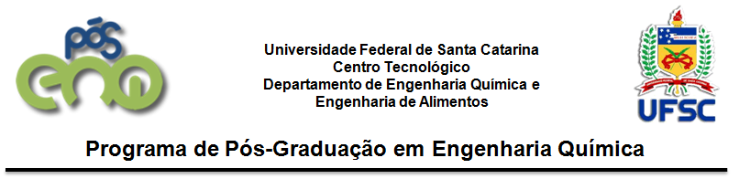
LETTER OF ACCEPTANCE FOR CO-ADVISORSHIP
City, date.

To the Graduate Course in Chemical Engineering at UFSC / PósENQ

I agree to be the co-advisor of the student XXXXXXXXXXX of the Graduate Program in Chemical Engineering at UFSC developing lecturing and orientation activities during his/her doctorate or master's studies together with his/her advisor Prof. Dr. XXXX.

Registration data:
- Name:
- Name of the mother:
- ID or Passaport (for foreigners):
- Nationality:
- Marital status:
- E-mail:

Signature:
Prof. Dr. XXXXXXXXX
Advisor

Signature:
Prof. Dr. XXXXXXXXX
Co-advisor

Please send this document, duly signed by the Advisor and by the Co-advisor, to the electronic address: ppgenq@contato.ufsc.br.

